Lab 04 – Worksheet

Name: Romaisa Shazad Myrah Hussain | ID: rb10107  mh10074 | Section:T2

Note: Assumptions and logics should be explained separately in tasks after the task results.

Task 1

Provide appropriately commented codes.
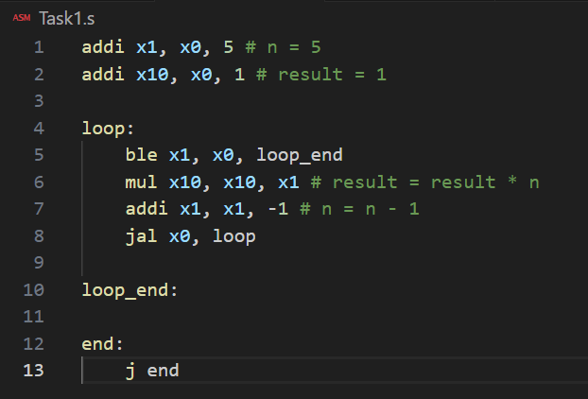

*Add snip of relevant Registers / Memory locations where you think results are obtained. Make sure the irrelevant area of snip is cropped. Make sure the irrelevant area of snip is cropped.
After Initial Code:

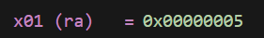

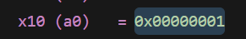

At the end:

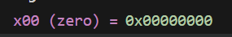

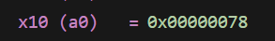

Comments

Initially storing 5 in n and 1 for result. In each iteration, the current value of x1 is multiplied by the result. The value of x1 is decremented by 1 till it reaches 0 then loop is terminated. (condition x1 less than equal to x0).

Task 2

Provide appropriately commented codes
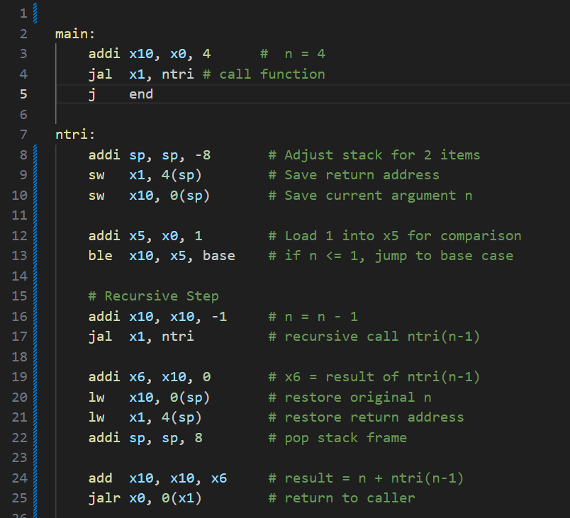
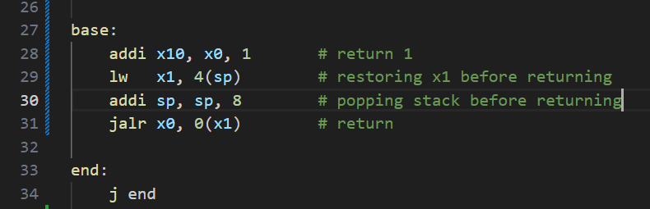

Add screenshot of your results

Loaded 1 into x5:
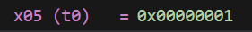

For n = 4 result is 10: (4+3+2+1):


Pointing to j end:

Sp at start:
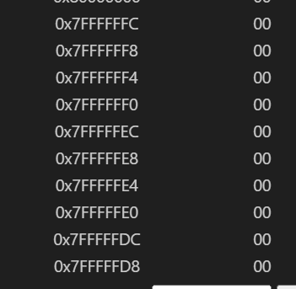

Sp at end:

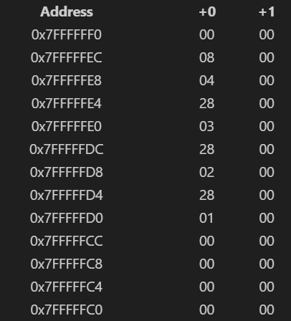

Comments
In main wrapper initialized n = 4 in register x10 and use jal x1, ntri to jump to ntri saving return address. Adjusting stack for 2 items and save return address and n. calculate n-1 and store it in x5. Used ble to check condition for base case. If x10 is less than or equal to x5 -> jump to base. (have stored value 1 in x5). If n > 1 then we move to recursive call. Code decrements x10 to set argument fo rntri(n-1) then performs recursive call. When the recursive call returns, the program restores original n and original return address from the stack and adds restored n to recursive call result.

Task 3

Provide appropriately commented codes
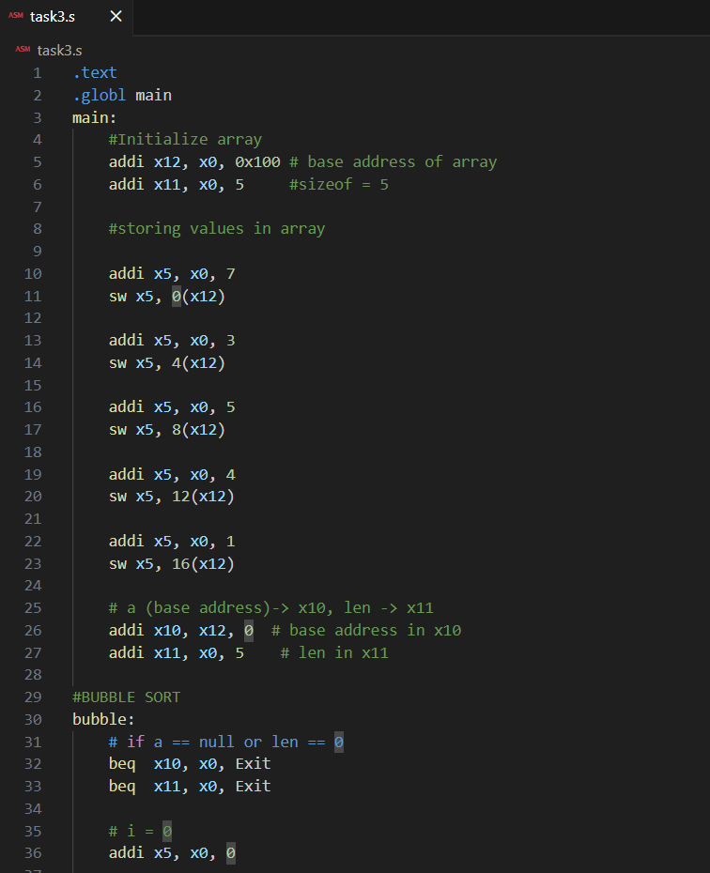
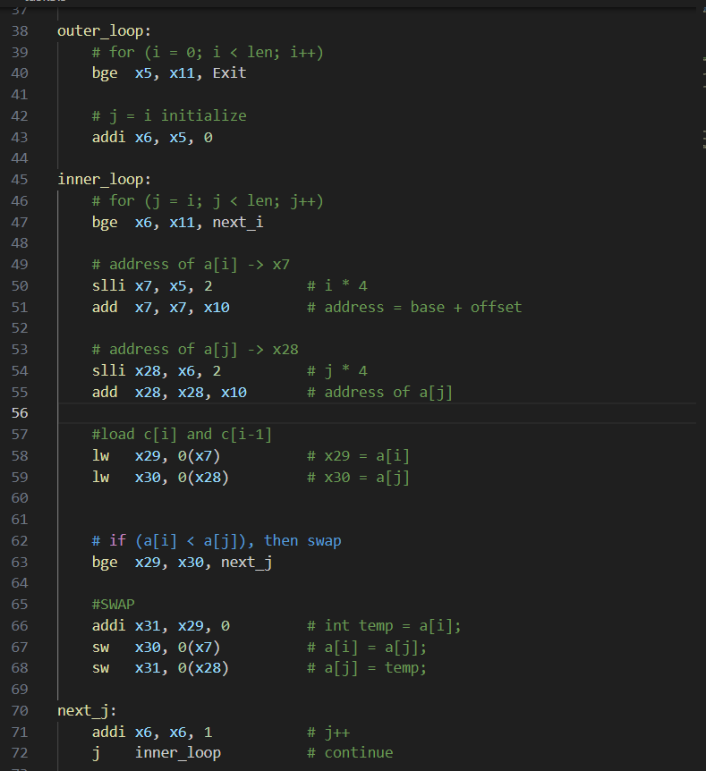
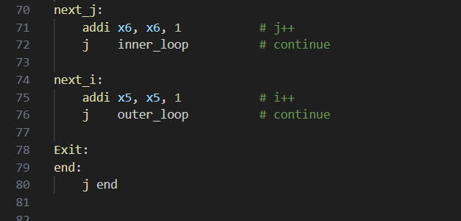

Add screenshots of your results
Before:
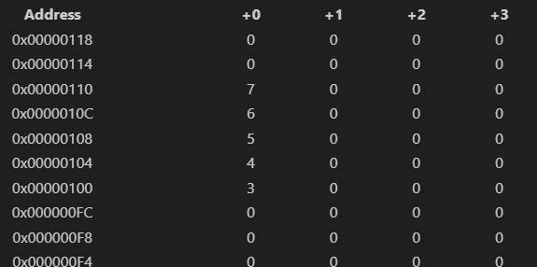

After:

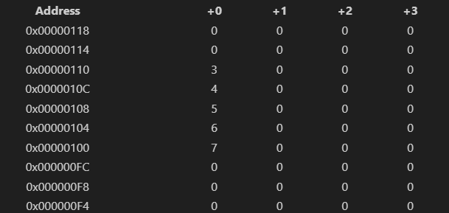

Comments:
This code implements an iterative bubble sort algorithm. First, we store an array of 5 integers starting from address 0x100. Starting address and len are passed as x10 and x11, respectively(as specified in the lab document).
The procedure is a leaf procedure because it does not call any other functions. It only uses unpreserved registers, so no stack management is required.
We have implemented a nested for loop:
- Outer Loop (x5/i): Iterates from 0 to len
- Inner Loop (x6/j): Initializes at the current value of i and scans to the end of the array.
The addresses of a[i] and a[j] are calculated by shifting the index left by 2 and adding to the base address. If a[i] >= a[j], the swap is skipped. If a[i] < a[j], a swap is performed using three instructions and a temporary register (x31) to hold the value of a[i] while a[j] is moved.

Task 4

Provide appropriately commented codes

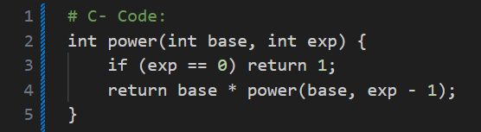

Risc – V code:

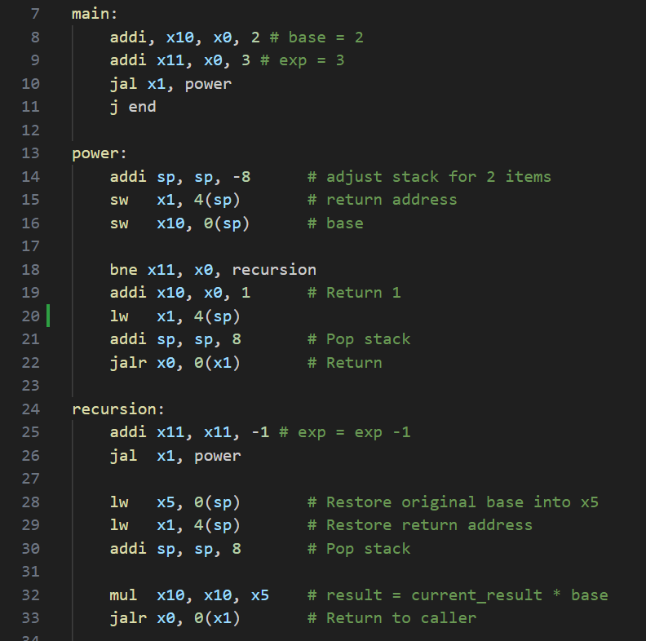
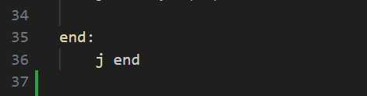

Add screenshots of your results
Result:

2 x 2 x 2 = 8:
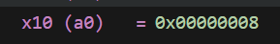

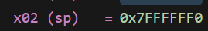

exponent decrements after each call (becomes 0 at end):
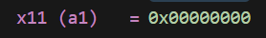

Stack restoration worked:
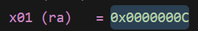

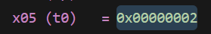 (base)

Stack Pointer at start:
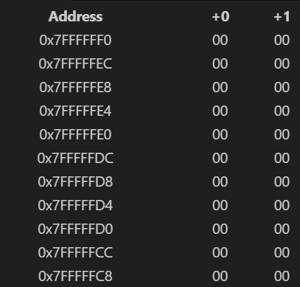

Stack Pointer at end:
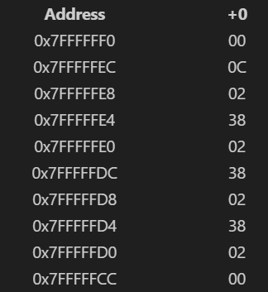

0C: the original return address to main

02: the original base value

38 the recursive return address

Comments:
2^3 = 2 x 2 x 2 = 8

In my main code, I set the base to 2 and the exponent to 3, then called the power function.
To make sure no data is lost, the code saves the return address and the base value onto the stack at the start of every call. Preserved x1 (ra) and x2 (sp) because they are Preserved Registers.
The function subtracts 1 from the exponent each time until it hits 0, which is the stop sign that returns a 1.
Then the function backtracks through the previous steps.

Lab 04 – Nest Procedures and Sorting

Assessment Rubrics

Points Distribution
Task No. | LR2  Code | LR 5  Results | AR 7  Report Submission & Github
Task 1 | /10 | /05 | /10 & /10
Task 2 | /10 | /10 | /10 & /10
Task 3 | /10 | /10 | /10 & /10
Task 4 | /15 | /10
Total Points | /100 Points
CLO Mapped | CLO 2
For description of different levels of the mapped rubrics, please refer the provided Lab Evaluation Assessment Rubrics and Affective Domain Assessment Rubrics.
# | Assessment Elements | Level 1: Unsatisfactory  Points 0-1 | Level 2: Developing  Points 2 | Level 3:Good  Points 3 | Level 4:Exemplary  Points 4
LR2 | Program/Code/ Simulation Model/ Network Model | Program/code/simulation model/network model does not implement the required functionality and has several errors. The student is not able to utilize even the basic tools of the software. | Program/code/simulation model/network model has some errors and does not produce completely accurate results. Student has limited command on the basic tools of the software. | Program/code/simulation model/network model gives correct output but not efficiently implemented or implemented by computationally complex routine. | Program/code/simulation /network model is efficiently implemented and gives correct output. Student has full command on the basic tools of the software.
LR5 | Results & Plots | Figures/ graphs / tables are not developed or are poorly constructed with erroneous results. Titles, captions, units are not mentioned. Data is presented in an obscure manner. | Figures, graphs and tables are drawn but contain errors. Titles, captions, units are not accurate. Data presentation is not too clear. | All figures, graphs, tables are correctly drawn but contain minor errors or some of the details are missing. | Figures / graphs / tables are correctly drawn and appropriate titles/captions and proper units are mentioned. Data presentation is systematic.
AR9 | Report | All the in-lab tasks are not included in report and / or the report is submitted too late. | Most of the tasks are included in report but are not well explained. All the necessary figures / plots are not included. Report is submitted after due date. | Good summary of most the in-lab tasks is included in report. The work is supported by figures and plots with explanations. The report is submitted timely. | Detailed summary of the in-lab tasks is provided. All tasks are included and explained well. Data is presented clearly including all the necessary figures, plots and tables.

